Title: Times New Roman, Bold, Font 14
Author names: Times New Roman, Bold, Font 10; spacing: before 3 pt,
after 6 pt. The authors of the abstract are indicated just after the abstract title.
Affiliation, e-mail: Times New Roman, Font 8; spacing: 0 pt, after 6 pt.
If there are several affiliations, these are indicated by numbers.
Conference abstract is limited to 1 page. Main text: Times New Roman, Font 10; single space, before/after: 0 pt; justify text. Page Layout: use the following page setup options: paper size A5; left (inside) margin 1.5 cm and right (outside) margin 1.0 cm; top and bottom margins 1.5 cm. The abstract should be written in English.

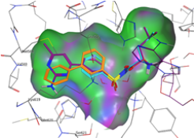

Figure 1. Title.

For Schemes please use ChemDraw drawings with ACS settings. Inserted ChemDraw drawings in CDX format are accepted. Figures in JPG or TIF format (at least 300 dpi) are accepted. Please number Figures and Schemes, assignment to Figures and Schemes should be made in the text.

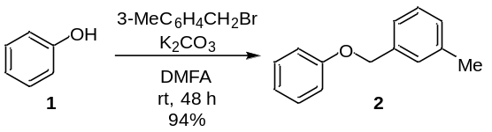
Scheme 1. Title.

References: citation numbers are included in the text as superscript indexes.¹ Use ACS style for references. Times New Roman, Font 9; single space: 0 pt, after 0, hanging 5 mm.

Acknowledgements
This section is optional.

References
- Karklins, A. B.; Kalnins, C. D.; Ozolins, E. J. Med. Chem. 2019, 62, 8931.

